IX INTERNATIONAL SYMPOSIUM ON AMERICAN STUDIES
(St. Petersburg, June 24–25, 2020)

“HISTORY OF AMERICAS: INDIVIDUAL, PEOPLE, CULTURES”

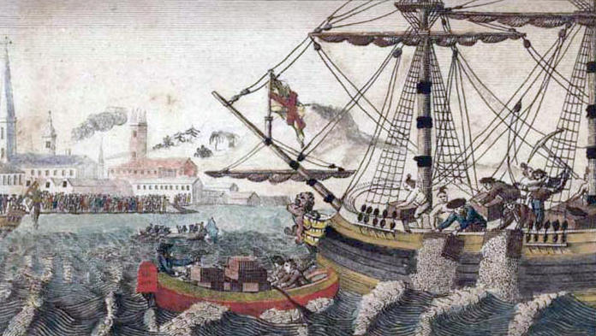

The Russian Association of American Anthropologists, the St. Petersburg Institute of History of the Russian Academy of Sciences, and the Institute of Ethnology and Anthropology of the Russian Academy of Sciences is pleased to announce that the 9th International Symposium of American Studies “History of Americas: Individual, People, Cultures” will take place in St. Petersburg, Russia, on June 24–25, 2020.
The focus of 9th International American Symposium, which continues the series of symposia of American studies in 1982–2018, is to showcase the latest results of historical and anthropological studies of the Americas, as well as celebrate the contribution of the school of academician A.A. Fursenko to Russian-American studies, and strengthen the Russian anthropological studies of the Americas.
The Symposium invites anthropologists from around the world to participate and submit proposals for the following themes:
– Historical anthropology and archeology of the peoples of the Americas
– The legacy of academician A.A. Fursenko
– Russian and foreign schools of anthropological studies of the Americas
We welcome proposals from undergraduate and graduate students of the American studies to the symposium’s round table discussion.
The submission deadline is January 25, 2020.
The submission guidelines:
1). FULL NAME: First and Last Name
2). Academic degree, place of work and position
3). Contact information: email, telephone
4). List of research Interests as well as the focus of previous research
5). Presentation title
6). Summary of the presentation (up to 200 words)
Working languages of the symposium: Russian, English, Spanish, and Portuguese.

